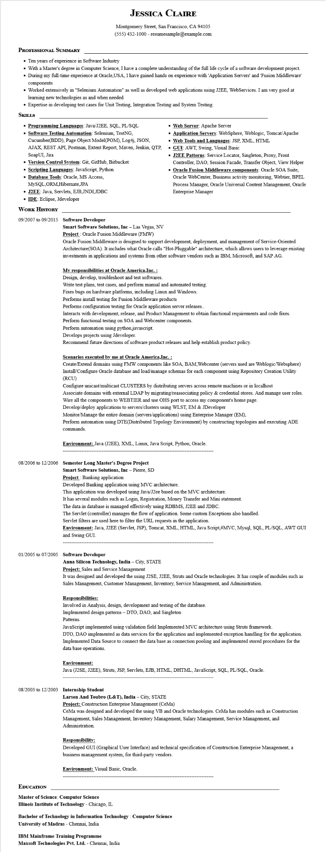
JESSICA CLAIRE
Montgomery Street, San Francisco, CA 94105 (555) 432-1000 - resumesample@example.com
PROFESSIONAL SUMMARY
• Ten years of experience in Software Industry
• With a Master's degree in Computer Science, I have a complete understanding of the full life cycle of a software development project. • During my full-time experience at Oracle,USA, I have gained hands on experience with 'Application Servers' and 'Fusion Middleware' components
• Worked extensively in "Selenium Automation" as well as developed web applications using J2EE, WebServices. I am very good at learning new technologies as and when needed
• Expertise in developing test cases for Unit Testing, Integration Testing and System Testing.
SKILLS
• Programming Languages: Java/J2EE, SQL, PL/SQL Software Testing Automation: Selenium, TestNG, Cucumber(BDD), Page Object Model(POM), Log4j, JSON,
AJAX, REST API, Postman, Extent Report, Maven, Jenkin, QTP, SoapUI, Jira
• Version Control System: Git, GitHub, Bitbucket
• Scripting Languages: JavaScript, Python
• Database Tools: Oracle, MS Access,
MySQL,ORM,Hibernate,JPA
• J2EE: Java, Servlets, EJB,JNDI,JDBC
• IDE: Eclipse, Jdeveloper
• Web Server: Apache Server
• Application Servers: WebSphere, Weblogic, Tomcat/Apache
• Web Tools and Languages: JSP, XML, HTML
• GUI: AWT, Swing, Visual Basic
• J2EE Patterns: Service Locator, Singleton, Proxy, Front Controller, DAO, Session Facade, Transfer Object, View Helper • Oracle Fusion Middleware components: Oracle SOA Suite, Oracle WebCenter, Business activity monitoring, Webtier, BPEL Process Manager, Oracle Universal Content Management, Oracle Enterprise Manager
WORK HISTORY
09/2007 to 09/2015 Software Developer
Smart Software Solutions, Inc - Las Vegas, NV
Project: Oracle Fusion Middleware (FMW)
Oracle Fusion Middleware is designed to support development, deployment, and management of Service-Oriented Architecture(SOA). It includes what Oracle calls "Hot-Pluggable" architecture, which allows users to leverage existing investments in applications and systems from other software vendors such as IBM, Microsoft, and SAP AG.
My responsibilities at Oracle America, Inc. :
Design, develop, troubleshoot and test softwares.
Write test plans, test cases, and perform manual and automated testing.
Fixes bugs on hardware platforms, including Linux and Windows.
Performs install testing for Fusion Middleware products
Performs configuration testing for Oracle application server releases..
Interacts with development, release, and Product Management to obtain functional requirements and code fixes. Perform functional testing on SOA and Webcenter components.
Perform automation using python javascript.
Develops projects using Jdeveloper.
Recommend future directions of software product releases and help establish product policy.
Scenarios executed by me at Oracle America, Inc.:
Create/Extend domains using FMW components like SOA, BAM,Webcenter (servers used are Weblogic/Websphere) Install/Configure Oracle database and load/manage schemas for each component using Repository Creation Utility (RCU)
Configure unicast/multicast CLUSTERS by distributing servers across remote machines or in localhost
Associate domains with external LDAP by migrating/reassociating policy & credential stores. And manage user roles. Wire all the components to WEBTIER and use OHS port to access my component's home page.
Develop/deploy applications to servers/clusters using WLST, EM & JDeveloper
Monitor/Manage the entire domain (servers/applications) using Enterprise Manager (EM),
Perform automation using DTE(Distributed Topology Environment) by constructing topologies and executing ADE commands.
Environment: Java (J2EE), XML, Linux, Java Script, Python, Oracle.
08/2006 to 12/2006 Semester Long Master's Degree Project
Smart Software Solutions, Inc - Pierre, SD
Project Banking application
Developed Banking application using MVC architecture.
This application was developed using Java/J2ee based on the MVC architecture.
It has several modules such as Login, Registration, Money Transfer and Mini statement.
The data in database is managed effectively using RDBMS, J2EE and JDBC.
The Servlet (controller) manages the flow of application. Some custom Exceptions also handled.
Servlet filters are used here to filter the URL requests in the application.
Environment: Java, J2EE (Servlet, JSP), Tomcat, XML, HTML, Java Script,#MVC, Mysql, SQL, PL/SQL, AWT GUI and Swing GUI.
01/2005 to 07/2005 Software Developer
Anna Silicon Technology, India - City, STATE
Project: Sales and Service Management
It was designed and developed the using J2SE, J2EE, Struts and Oracle technologies. It has couple of modules such as Sales Management, Customer Management, Inventory, Service Management, and Administration.
Responsibilities:
Involved in Analysis, design, development and testing of the database.
Implemented design patterns - DTO, DAO, and Singleton
Patterns.
JavaScript implemented using validation field Implemented MVC architecture using Struts framework.
DTO, DAO implemented as data services for the application and implemented exception handling for the application. Implemented Data Source to connect the data base as connection pooling and implemented stored procedures for the data base operations.
Environment:
Java (J2SE, J2EE), Struts, JSP, Servlets, EJB, HTML, DHTML, JavaScript, SQL, PL/SQL, Oracle.
08/2003 to 12/2003 Internship Student
Larsen And Toubro (L&T), India - City, STATE
Project: Construction Enterprise Management (CeMa)
CeMa was designed and developed the using VB and Oracle technologies. CeMa has modules such as Construction Management, Sales Management, Inventory Management, Salary Management, Service Management, and Administration.
Responsibility:
Developed GUI (Graphical User Interface) and technical specification of Construction Enterprise Management, a business management system, for third-party vendors.
Environment: Visual Basic, Oracle.
EDUCATION
Master of Science: Computer Science
Illinois Institute of Technology - Chicago, IL
Bachelor of Technology in Information Technology: Computer Science
University of Madras - Chennai, India
IBM Mainframe Training Programme
Maxsoft Technologies Pvt. Ltd. - Chennai, India

